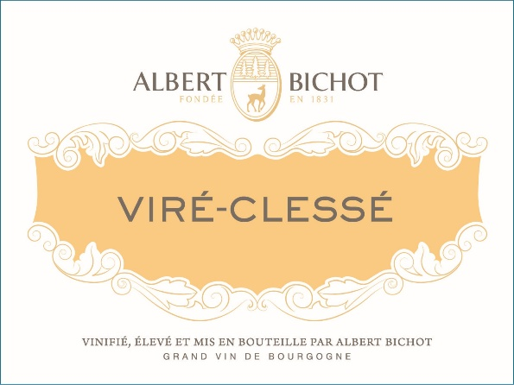

[Albert Bichot Viré-Clessé 2022](https://www.winespectator.com/wine/wine-detail/id/1311179/name/albert-bichot-vir%C3%A9-cless%C3%A9-2022)