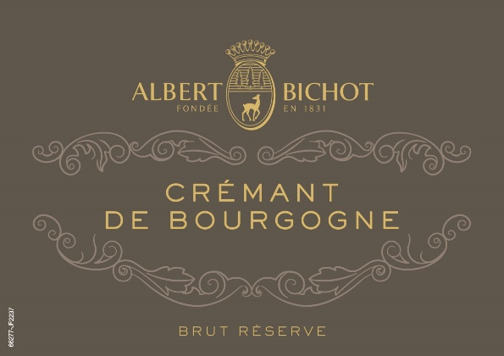

[Albert Bichot Brut Crémant de Bourgogne Réserve NV](https://www.winespectator.com/wine/wine-detail/id/457220/name/albert-bichot-brut-cr%C3%A9mant-de-bourgogne-r%C3%A9serve--1)