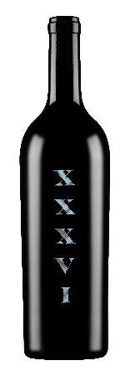

**Merryvale Profile XXXVI – 97 points**

This ultra-rare, once-off bottling- a multi-vintage blend that includes wine from a spate of vintages from 1983- offers a fascinating and timeless character. It captures the essence of decades in the glass, immediately drawing you in with notes of currants, dried rose petals, and dusty minerality. The tannins are beautifully fine, seamlessly integrated, and form a foundation for a host of complex and intriguing layers. Hints of loamy earth, pressed flowers, black tea, and black truffle mingle while an impressive freshness elevates the wine, defying expectations. Winemaker Jeff Crawford achieved this remarkable feat by opening older wines, many from large format bottles, blending them under inert gasses, and allowing the blend to rest for roughly six months in neutral barrels to achieve harmony. The result is a captivating marriage of old and young fruit, delivering generosity, complexity, and history in every sip.

Tasted by: Jonathan Cristaldi

(at Merryvale, St. Helena, California, 15 Dec 2024)

Drinking Window: 2025 – 2036

[Merryvale, Profile XXXVI, Napa Valley, California, USA](https://www.decanter.com/wine-reviews/usa/california/merryvale-profile-xxxvi-napa-valley-california-usa-91637)