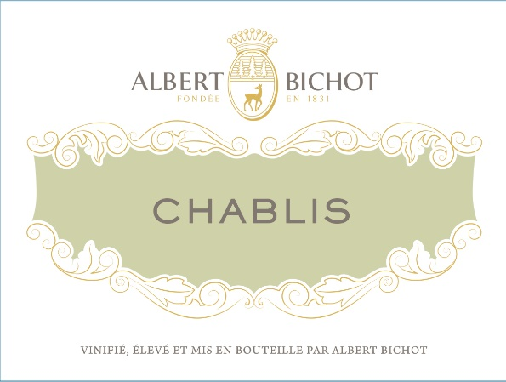

[Albert Bichot Chablis AOC 2022](https://www.winespectator.com/wine/wine-detail/id/1311183/name/albert-bichot-chablis-2022)