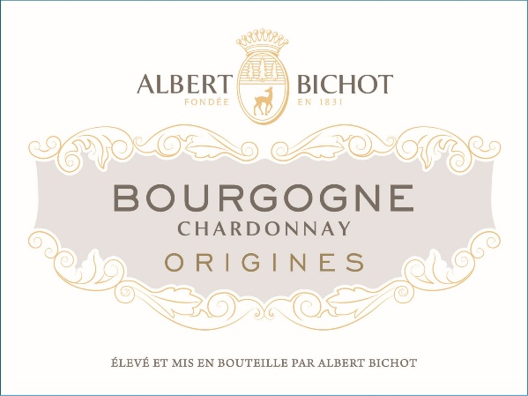

[Albert Bichot Bourgogne Origines Chardonnay 2022](https://www.winespectator.com/wine/wine-detail/id/1311178/name/albert-bichot-bourgogne-white-origines-2022)