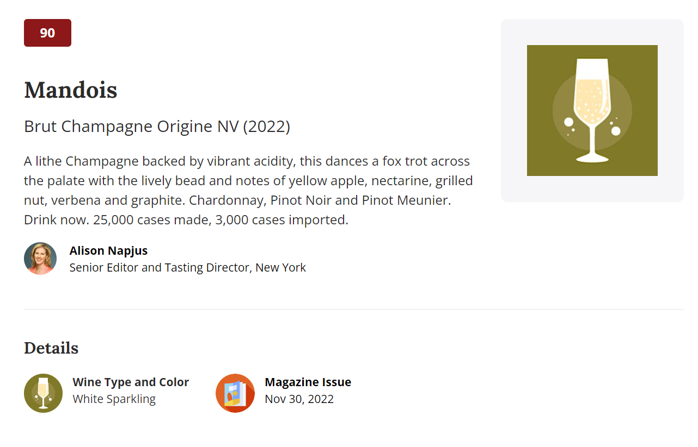

[Minervois-la-Liviniere-2020](https://www.winespectator.com/wine/wine-detail/id/1293522/name/vignobles-lorgeril-minervois-la-livini%C3%A8re-domaine-la-borie-blanche-terriors-d%27altitude-2020)