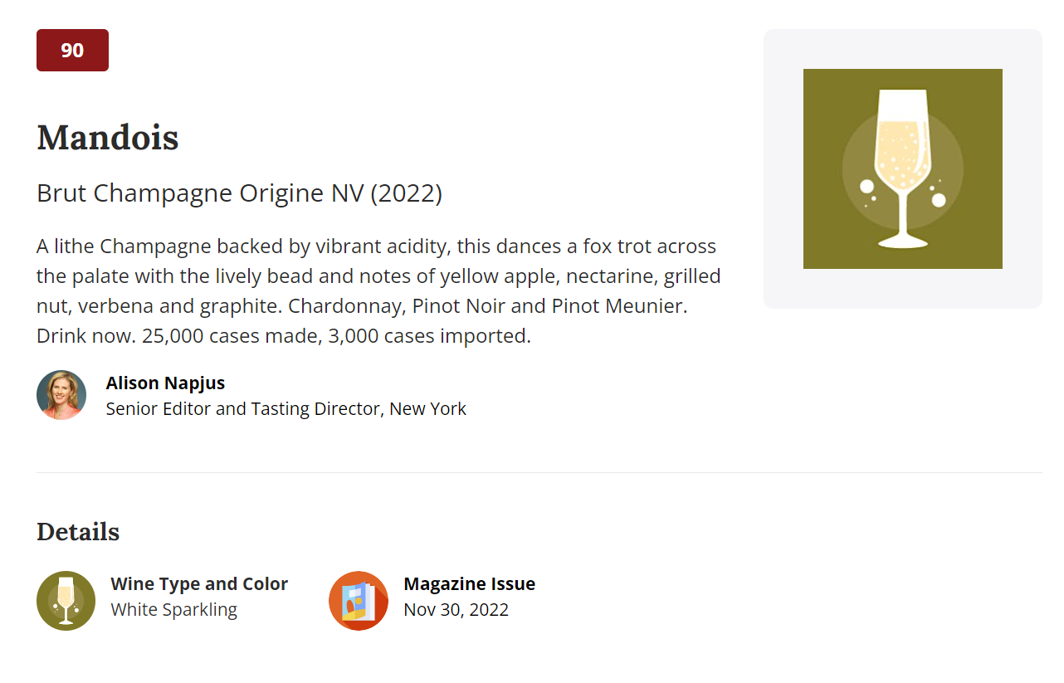

[Chateau-de-Pennautier-Cabardes-2020](https://www.winespectator.com/wine/wine-detail/id/1293523/name/vignobles-lorgeril-cabard%C3%A8s-ch%C3%A2teau-de-pennautier-terriors-d%27altitude-2020)